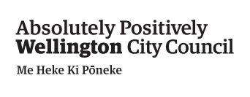
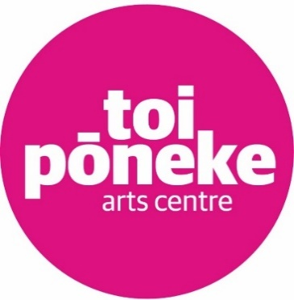
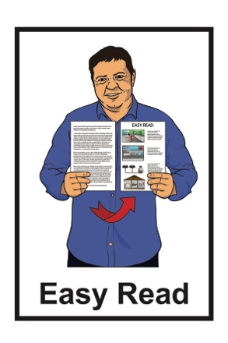

Information about a new

arts residency at

Toi Pōneke Art Centre for

deaf / Deaf and disabled artists
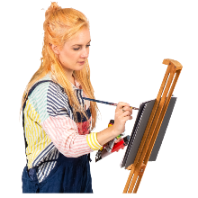
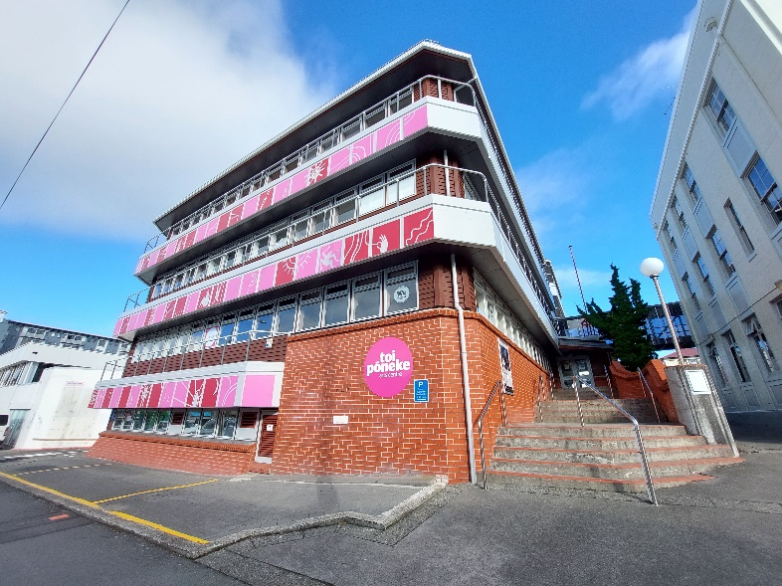

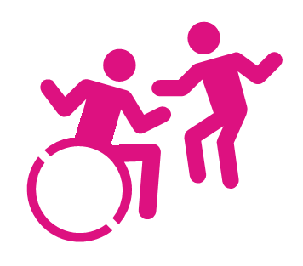

July 2022

Before you start

This is a long document.

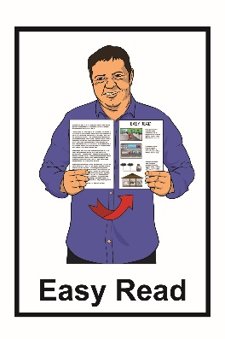
While it is written in Easy Read it can be hard for some people to read a document this long.

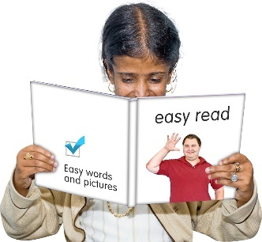
Some things you can do to make it easier are:

- read a few pages at a time
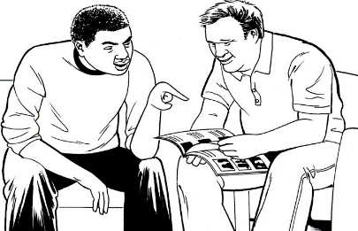
- have someone to help you understand it.

What you will find in this document

Page number:

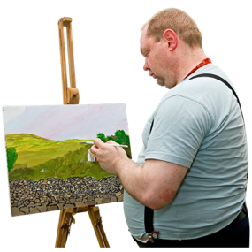
What is this document about? 4

What is this residency? 8
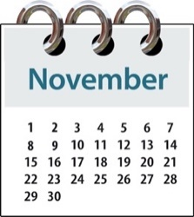

Key dates you need to know 10

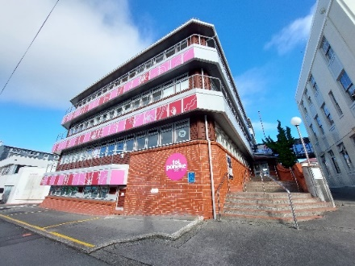
Information about the residency 12

What kind of art can you do? 17

Who can apply? 20

Page number:
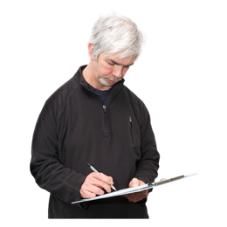

What are we looking for? 23

How we will choose the artist for
the residency 26

Toi Pōneke residency
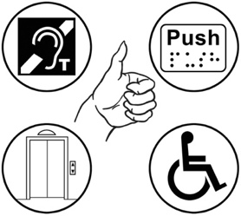
agreement 28

Information about accessibility 29
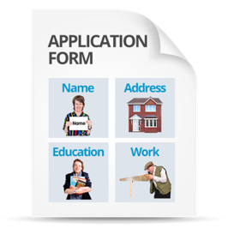

How to apply 32

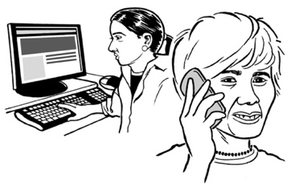
How to contact us 38

What is this document about?

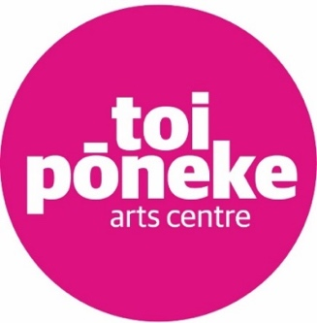
This Easy Read is about a brand new arts residency at Toi Pōneke Arts Centre.

Toi Pōneke Arts Centre is a creative space for artists in Wellington.

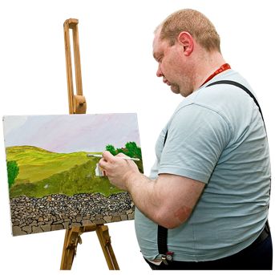
An arts residency is when someone is given a space where they can make and display their art.

This is a brand-new pilot arts residency for artist who are:

- deaf / Deaf

- disabled.

It is called a pilot residency as this is the first time it has been offered.

In this document when we say deaf / Deaf we mean a person who has any kind of hearing impairment or hearing loss.

We use deaf / Deaf to be inclusive for those who identify as Deaf with their own languages.

In this Easy Read document we will say deaf to mean both deaf / Deaf.

In this document when we say disabled people we mean people who have been disabled by the way the world we live in that puts barriers up that make it hard for disabled people to live the lives they choose.

We use this language as it is used by the Office for Disability Issues as part of the New Zealand Disability Strategy.

You can read the Easy Read version of the New Zealand Disability Strategy at the Office for Disability Issues website here:

https://bit.ly/3IzT6MR
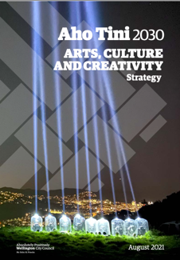

We also use this same language in the Aho Tini 2030 Arts, Culture and Creativity Strategy which looks at arts and culture in Wellington City.

You can find out more about the Aho Tini 2030 strategy at the Wellington City Council website:

https://bit.ly/3yGYrxe
In this Easy Read document you can find out:

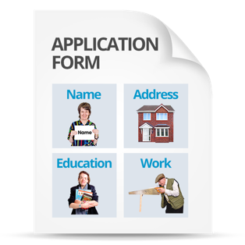
- what the Toi Pōneke arts residency is about

- how to apply for the residency.

What is this residency?

This residency will give 1 artist a space at Toi Pōneke to make their artwork.
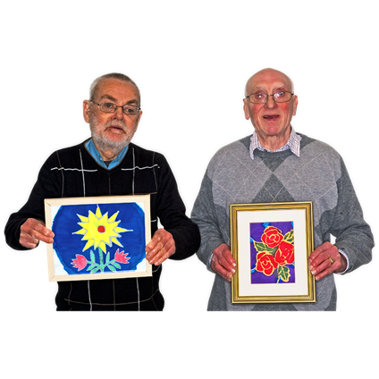

The artist who is chosen will be called the artist in residence.

We want to make the chosen artist feel like they are part of the Toi Pōneke community.

This is the first time we have offered this residency.

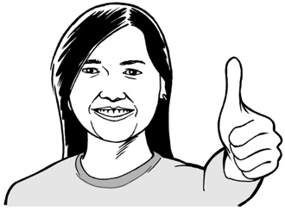
We know it might take some time for us to make sure everything works as well as it should.

Our aim for this residency is to:
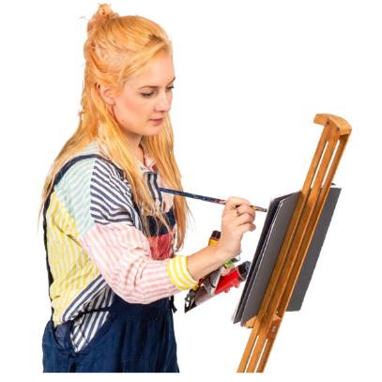
- offer more opportunities for deaf / disabled artists

- give a deaf / disabled artist a better chance of getting their artwork seen by other people.
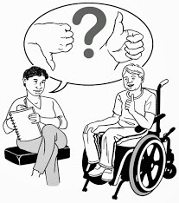

The chosen artist will work with us to create a strong and accessible opportunity for disabled artists.

Key dates you need to know

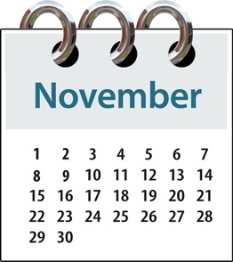
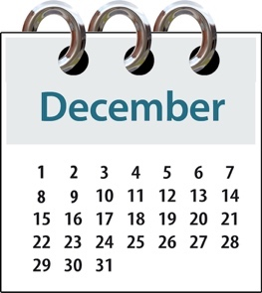
The residency will run for 6 weeks from:

- 1 November 2022
to
- 9 December 2022

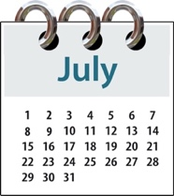
The time you can send us your application is from:
- 21 July 2022

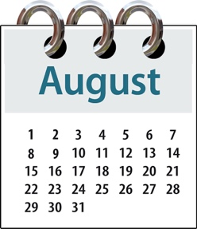
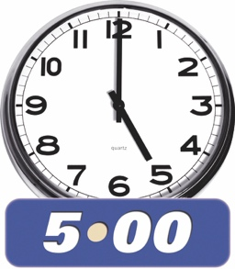
to

- 5pm on 15 August 2022

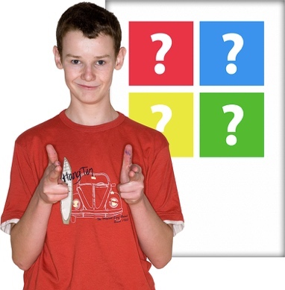
In September 2022 / October 2022
we will:

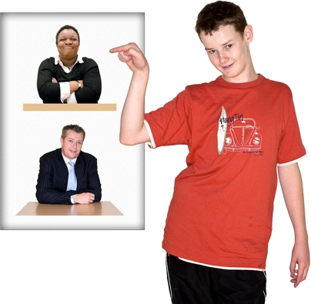
- tell you if you have been chosen for the residency

- let other people know who we have chosen.

Information about the residency

The residency is open for 1 artist in Wellington / Te Whanganui-a-Tara who is:
- deaf / Deaf

- disabled.

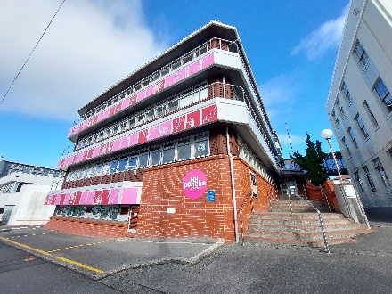
The residency will be based at
Toi Pōneke Arts Centre in the city.

The address for Toi Pōneke Arts Centre is:

61 / 69 Abel Smith Street

Te Aro

Wellington 6011
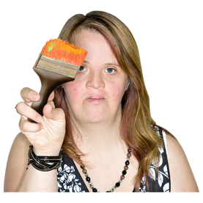
The chosen artist will work on new artwork during the residency.

The residency is 2 weeks longer than most other residencies at
Toi Pōneke Arts Centre.

This is so the chosen artist has more time to work in a flexible way.

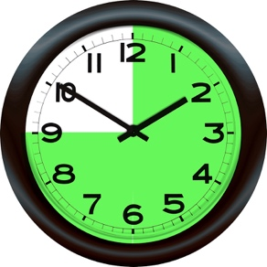
The number of hours that the residency covers is 1 hundred and 44 hours.

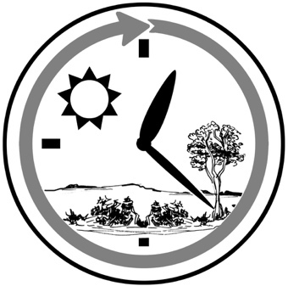
This is around 24 hours a week.

24 hours is as long as 1 day.

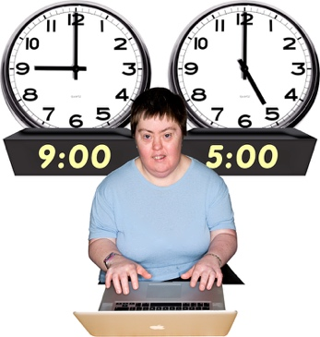
You can choose how many hours you want to work in each week.

The artist will be paid 3 thousand
7 hundred and 50 dollars to do this residency.

This is the total amount of money before tax is taken.

Tax is money you pay to the government.

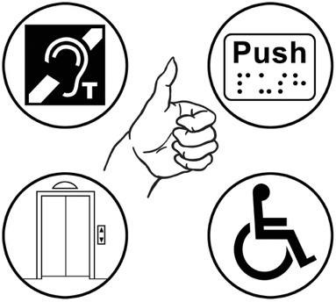
The chosen artist will get support for any accessibility needs they have that might impact how they work.

You can read more about accessibility on page 29 of this document.
The chosen artist can also be supported by a paid mentor of their choice if they want one.

A mentor is someone who will support you by:

- giving you advice / guidance

- sharing their skills / experience.

At the end of the residency the artist can show their work to invited guests.

The people who work at Toi Pōneke called staff will be able to assist you if you need them to.

Toi Pōneke staff can assist you with:

- putting together any items you need to show your work

- setting up your work ready to show other people.
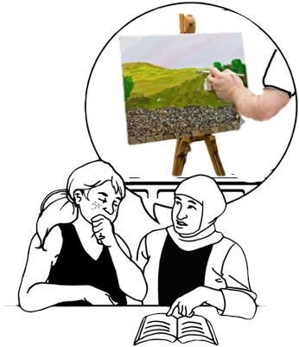

After the residency you will be given advice and support on how you could continue your work as an artist.

This includes things you can do to have more chance of being chosen to show your work at Toi Pōneke.

What kind of art can you do?

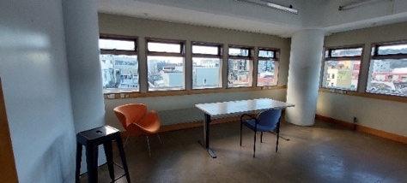
The artist will have the use of a studio room that is the size of:

- a little over 3 meters wide
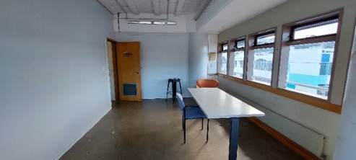
by

- 5 and a half meters long.

This is about the size of a garage for 1 car.

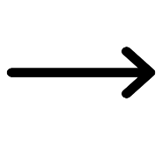
The door to the room is 76 centimetres wide.

This is about as wide as a door you have inside your house.

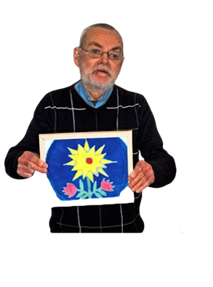
The residency is best suited for artwork that is:

- 2 dimensional like images
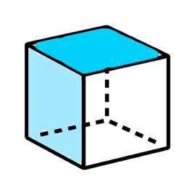
- 3 dimensional like objects you make.

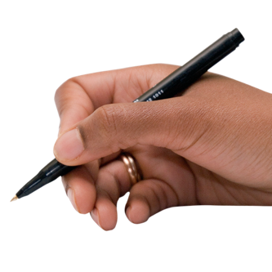
The sorts of artwork you could do on this residency are things like:

- writing
- drawing / painting

- sculpture which is making 3 dimensional objects
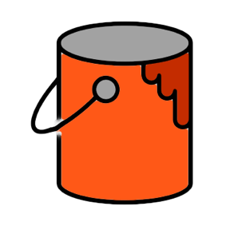
- printing which is using ink / paint to transfer a design

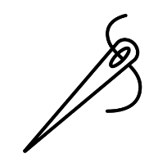
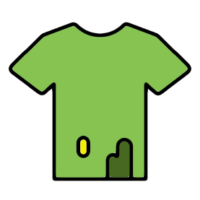
- textiles which is work with fabric

- mixed media.
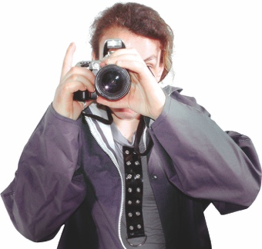
Other kinds of art you could do on this residency are things like:

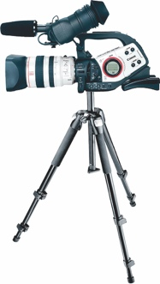
- photography

- video art.

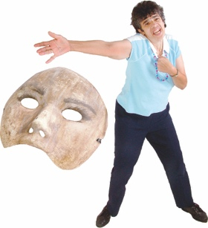
This arts residency is not suitable for:

- performing arts
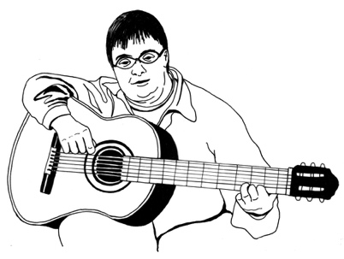
- music

- very large pieces of work.

You can contact Belinda Campbell who is the Public Programmer at Toi Pōneke if you have any questions.

You can find her contact details on page 38 of this document.

Who can apply?

Artists who apply for the residency must be:

- a deaf person
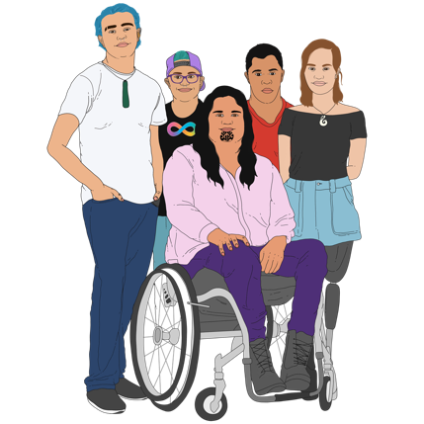
- a disabled person

or

- identify as having a disability / impairment.
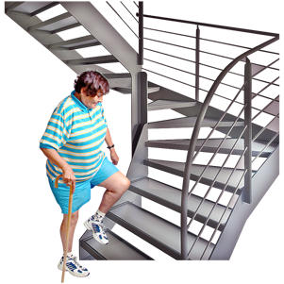

An impairment can affect:

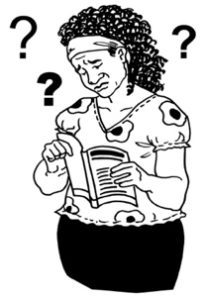
- your body

- your brain.

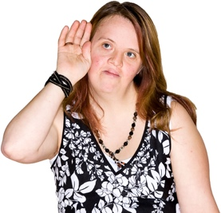
Some examples of impairments are things like:
- not being able to hear very well

- not being able to see very well

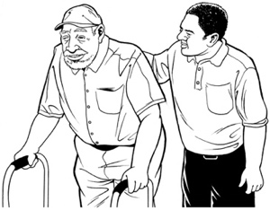
- not being able to move around very easily.

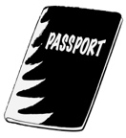
Artists who apply for the residency must also be:

- a New Zealand citizen

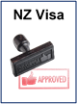
or

- a New Zealand permanent resident.

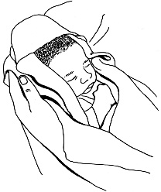
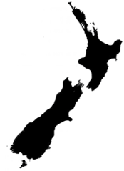
A New Zealand citizen is someone who was born in New Zealand.

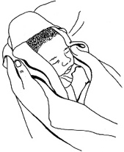
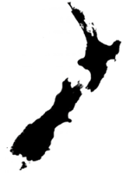
A New Zealand permanent resident is someone who:

- was not born in New Zealand
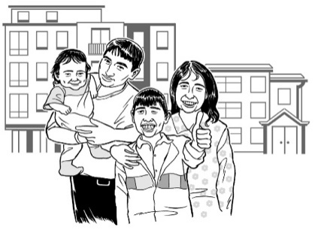
- has been told by the government they can live in New Zealand all the time.
You do not need to have a university degree in the arts to apply for the residency

but

you should be working as an artist in some way.

What are we looking for?

We want to hear from artists who have ideas for an art project that:

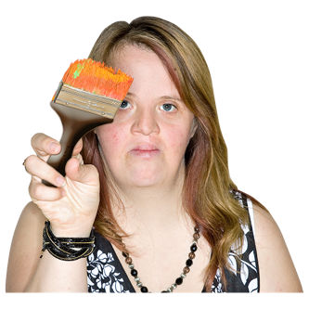
- is a new idea you want to explore

- does things that can make your skills as an artist even better.

We also want to hear about projects that can take your current way of making art to a higher standard.
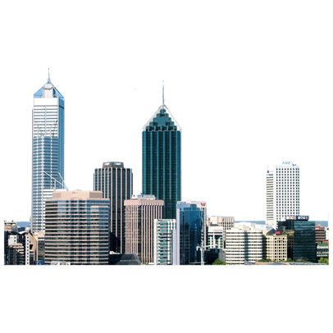

We are looking for an artist who:

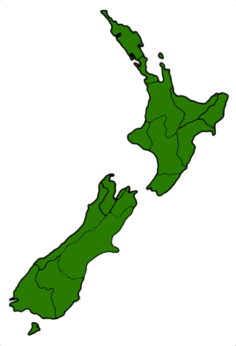
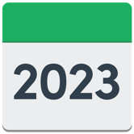
- lives in Wellington City

- will stay in New Zealand for at least 1 year after they finish the residency.
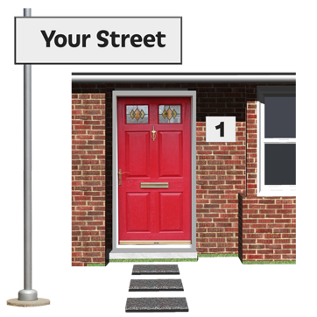
You must be able to prove that you have lived in Wellington City:

- most of the time

- for the past 3 years.

You must have a current Wellington City address at the time when you apply for the residency.

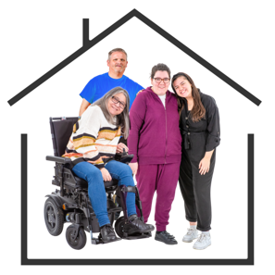
If you are shortlisted for the residency you will need to prove:

- your Wellington City address

- if you are a New Zealand:

- citizen
or

- permanent resident.
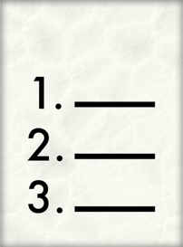
Shortlisted means you are:

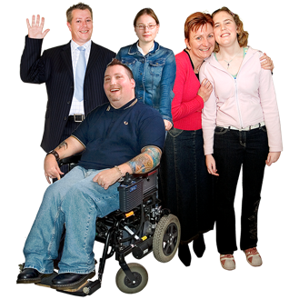
- part of a small list of people chosen from a longer list

- part of a group of people who are the most suited for a job or prize.

We will choose 1 artist from the shortlist for the residency.

How we will choose the

artist for the residency

Your application will be looked at by group of people called a panel chosen by Toi Poneke.

A panel is a group of people who work together to make decisions.

The panel will also include disabled people.

The panel will choose the artist they think should get the residency.

The artist who has the best chance of being chosen will be able to show:

- a clear idea of the aims of their art project
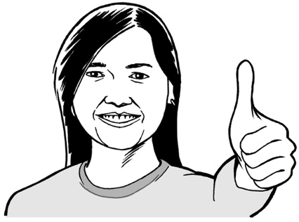
- how they think this residency will give them good opportunities for the future.

Toi Pōneke residency agreement

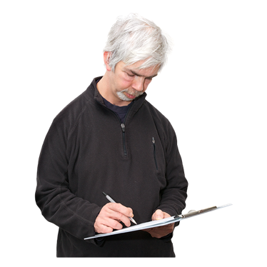
The artist who is chosen for the residency must sign the Toi Pōneke residency agreement before they will be given any money.

This a document that sets out all important information about the residency which must be agreed to by:
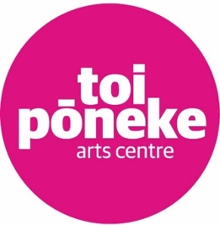
- the chosen artist

- Toi Pōneke.

You can find more information about the residency agreement on the
Toi Pōneke website at:

https://toiponeke.nz

Information about accessibility

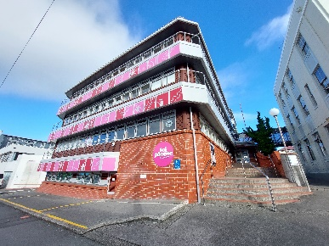

Toi Pōneke is an older building that has:

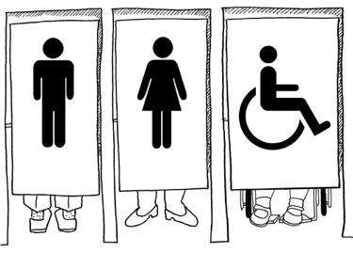
- entrances that can be used by wheelchair users

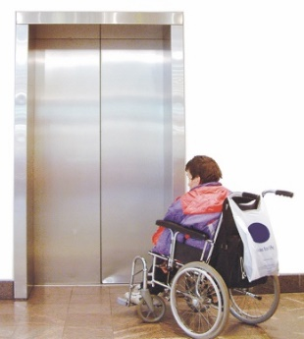
- accessible toilets on the ground floor

- a lift on the ground floor.

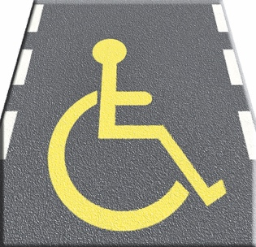
There is some accessible parking spaces behind the building.

The studio space for the residency is on the second floor of the East building.

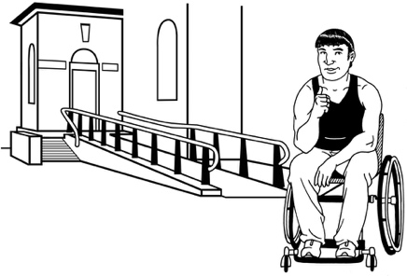
You can access the East building by a ramp from the central driveway.

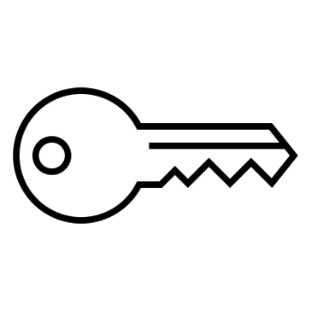
The chosen artist will be given:

- a key to the studio door
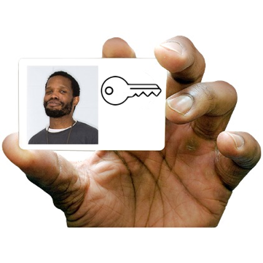
- a swipe card so they can get into the Toi Pōneke building after usual opening hours.

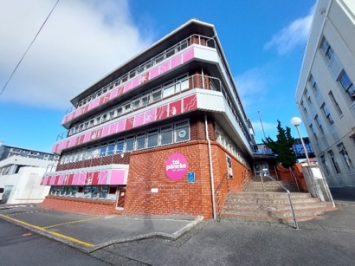
You are welcome to visit Toi Pōneke to see if it is accessible to you before you apply for the residency.

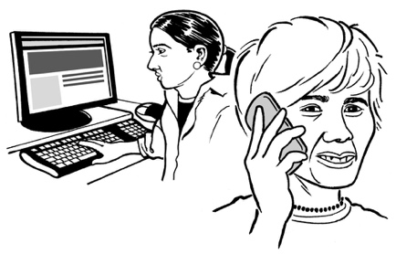
You can contact Belinda Campbell who is the Public Programmer to arrange this.

You can find her contact details on page 38 of this document.

You can also find more information about accessibility on the Access Page of the Toi Pōneke website at:

https://toiponeke.nz/access

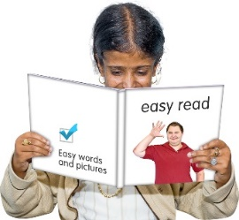
The information on this website is not in Easy Read.

How to apply

Your application for this residency must include:

- your completed application form
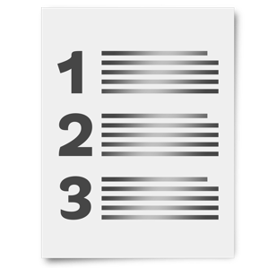
- a short CV

- 3 images of your work.

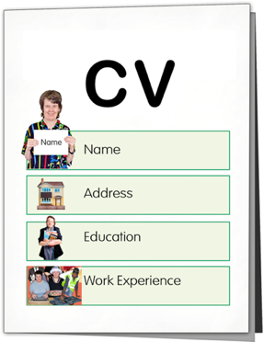
A CV is a document that shows:

- what kind of education you have

- what kinds of work you have done

- your skills / experience.

You can also include links to your work on the internet to support your application such as:

- websites

- places you can share videos.

You will need to upload your application files to a OneDrive link.

Upload means you send something like a document from a computer to a website on the internet.

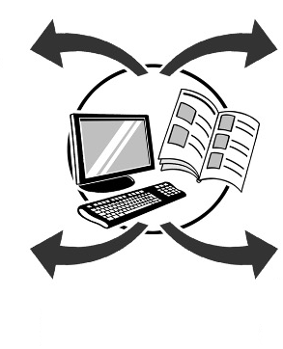
You can upload your information in:

- 1 file

or

- more than 1 file.
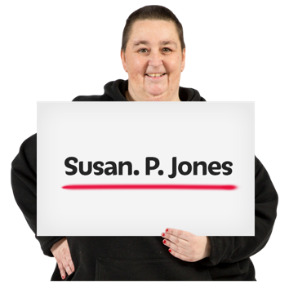
You must make sure that your own name is included in all your file names.

You can download the residency application form from this website:

https://tinyurl.com/4s5dfxwu

Your application form must include
your contact information like:

- your name
- your email address

- your phone number.

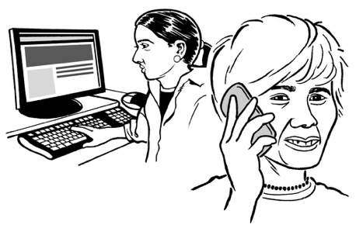
You should also tell us how you would like us to contact you.

Your application form must also include your answers to some questions on the form like:

- what kind of art you do / are interested in
- what kind of art you want to make

- what doing this residency would mean to you.
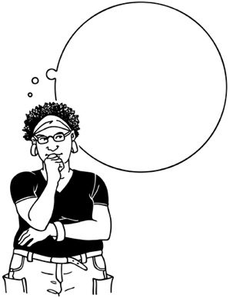

You should make sure you think about how long your work will take to make.

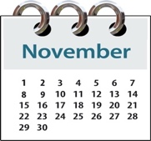
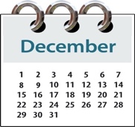
It is important you are sure you can make your work in the amount of time that the residency covers.

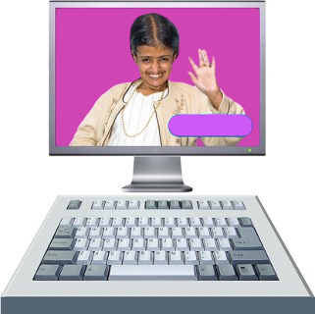
If you would feel more comfortable doing so it is okay to answer the questions on the application form in:

- a video

- an audio file.

You should upload your completed application form to the OneDrive link at:

https://tinyurl.com/2zu6rpcr

Before you upload your application you should do a final check to make sure it includes:

- your contact information
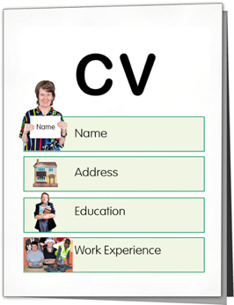
- your answers to the questions on the application form

- a short CV
- 3 images of your work

- any links that you would like to include with your application.

You must make sure you include your own name in the name of all the files you upload.

It is okay to ask a friend / family member to support you to complete this application.

How to contact us

You should contact Belinda Campbell who is the Public Programmer at Toi Pōneke Arts Centre if you:

- have any questions about the residency

- need any assistance to fill in your application form.

You can contact Belinda:

- by email at:

Belinda.Campbell@wcc.govt.nz
- by phone on:

021 659 883
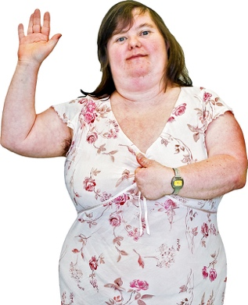
Please use the pronouns she / her when you contact Belinda.

Pronouns are part of how someone chooses to show their identity.

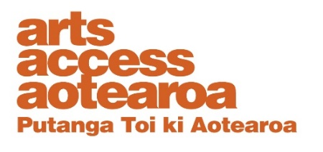
You can also contact Arts Access Aotearoa for advice / support:

- by email at:

info@artsaccess.org.nz
- by phone on:

04 802 4349

This information has been written by Wellington City Council.
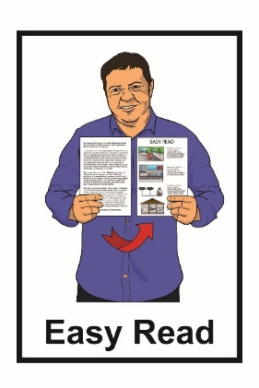
It has been translated into Easy Read by the Make It Easy service of People First New Zealand Inc. Ngā Tāngata Tuatahi.

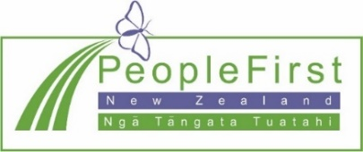
The ideas in this document are not the ideas of People First New Zealand Inc. Ngā Tāngata Tuatahi.
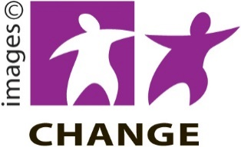
Make It Easy uses images from:

- Changepeople.org
- Photosymbols.com
- Sam Corliss
- Huriana Kopeke-Te Aho

All images used in this Easy Read document are subject to copyright rules and cannot be used without permission.

